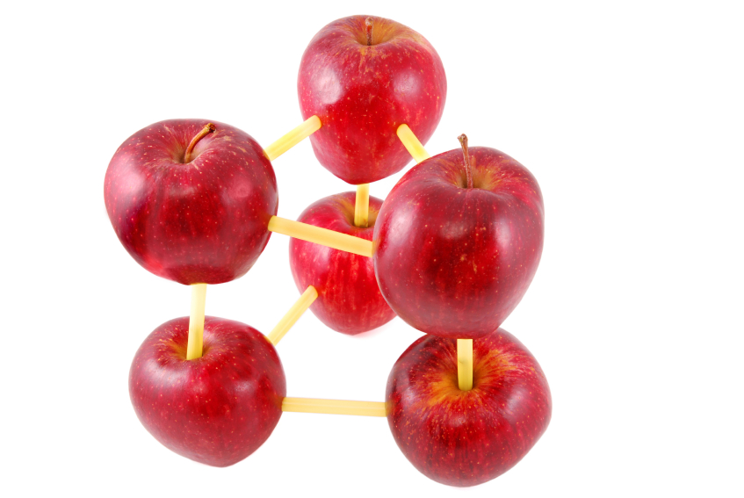

The 12 Principles of Green Chemistry

1. It is better to prevent waste than to treat or clean up waste after it is formed.
2. Synthetic methods should be designed to maximize the incorporation of all materials used in the process into the final product.

3. Wherever practicable, synthetic methodologies should be designed to use and generate substances that possess little or no toxicity to human health and the environment.

4. Chemical products should be designed to preserve efficacy of function while reducing toxicity.

5. The use of auxiliary substances (e.g. solvents, separation agents, etc.) should be made unnecessary whenever possible and, innocuous when used.

6. Energy requirements should be recognized for their environmental and economic impacts and should be minimized. Synthetic methods should be conducted at ambient temperature and pressure.

7. A raw material feedstock should be renewable rather than depleting whenever technically and economically practical.
8. Unnecessary derivatization (blocking group protection/deprotection, temporary modification of physical/chemical processes) should be avoided whenever possible.

9. Catalytic reagents (as selective as possible) are superior to stoichiometric reagents.

10. Chemical products should be designed so that at the end of their function they do not persist in the environment and break down into innocuous degradation products.

11. Analytical methodologies need to be further developed to allow for real-time in-process monitoring and control prior to the formation of hazardous substances.

12. Substances and the form of a substance used in a chemical process should be chosen so as to minimize the potential for chemical accidents, including releases, explosions, and fires.

