In- class activity guide: For students

Activity 1: Pick the solution that you think is the best of three

Activity 2: Critiquing 5 different solutions

Things to keep in mind:
- You are the user
- You live on less than $2 per day
- You have limited, unreliable access to electricity, clean water, sanitation, quality education and healthcare.
- Brainstorm and fill this table: try to come up with more critiques than pros.

- Sun king solar lantern: A sturdy, long lasting solar lantern that can charge cellphones. Costs apprx. $35.

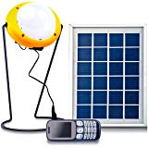

I would buy it because… | I would not buy it because…

- The XO laptop: A sturdy, low electricity consuming children’s laptop created under the program “One Laptop Per Child”. 1 GB memory. Costs apprx. $200.

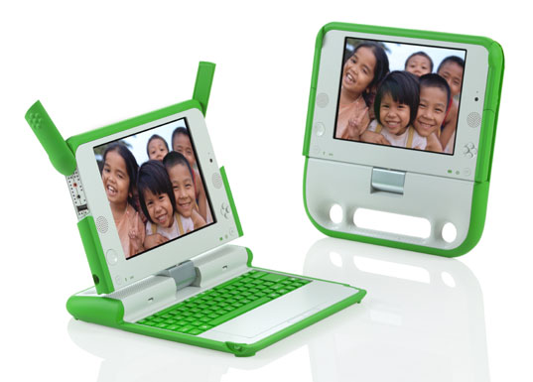

I would buy it because… | I would not buy it because…

- Zeer pot: Evaporative cooling DIY clay pot-in-pot refrigeration device for fruits and vegetables.
Has a layer of wet sand in between the two pots. As the moisture evaporates it cools the inner pot, keeping up fruit and vegetables fresher for longer. Doesn’t need electricity. Must add water two times a day. Costs apprx. $5-$25 depending on size. Suited for dry, low humid conditions.

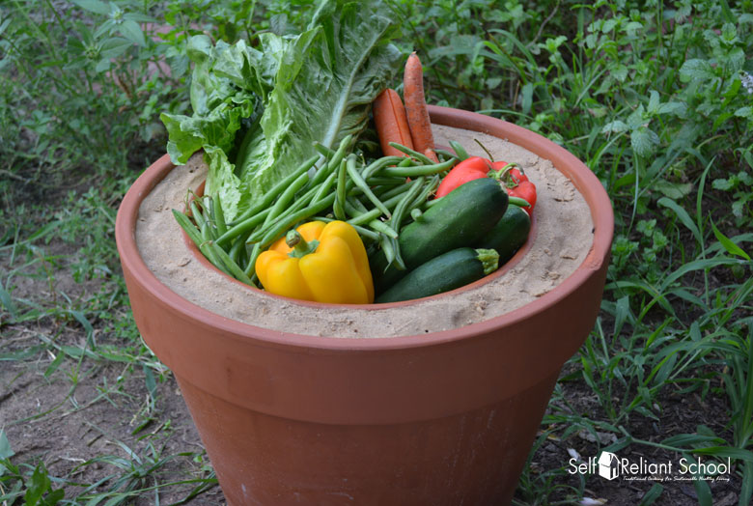

I would buy it because… | I would not buy it because…

- Box solar cooker:

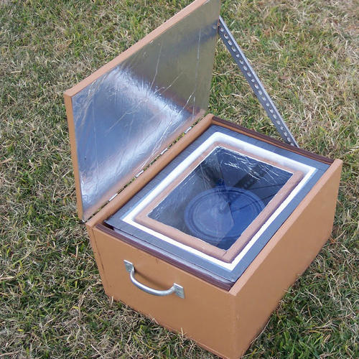

I would buy it because… | I would not buy it because…

- Treadle pump:

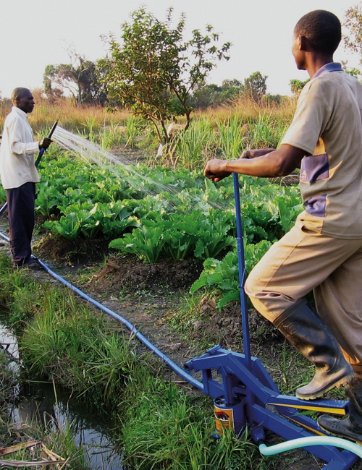

I would buy it because… | I would not buy it because…

Activity 3: Learn- interviewing the user

How to interview: Things to keep in mind
- The focus here is (thematic area _________) in your school. Hence the interview will focus on understanding the challenges users are facing and specific needs they have for a solution with respect to that.
- Ask why- Even when you think you know the answer – try to understand why this is really a challenge.
- Pay attention to nonverbal cues - Be aware of body language and emotions.
- Ask open-ended questions that do not suggest answers. For example, “What do you think about the library?” is better than “Don’t you think the library is great?”
- Make sure to write down exactly what the person says, not what you think they might mean. Ask clarifying questions if you don’t understand what they’re saying.
- In a team of three students- 1 asks the questions, 2 writes down the answers, 3 observes and makes observation notes.

Sample interview guide: Start with general questions and then dig deeper. Add your own follow up questions where needed.

- What is your overall impression of the (thematic area)?
- What are some things you like about this (thematic area)?
- Why do you like those things? Dig deeper into each one.
- What are some things you don’t like or wish to be changed/improved about this (thematic area)?
- Why? Dig deeper into each one.
- How do those things affect you?
- How would you like to see those things changed or improved? Why?

Activity 4: Imagine
4 a. Select a problem: From the list of challenges your user told you, you have to select one to work on. Select a challenge that is: important to the user, practical to solve with the time and resources you have, and the whole team is excited to take on. Once you have selected your challenge, use this guide to create a challenge statement. 2 min.

And then you have to define the challenge: Follow this guide to define your challenge.

(User/ group name)

needs a way to _______________________________________________________________________
(User need)

because _____________________________________________________________________________
(insight as to why)

But, ________________________________________________________________________________.
(current situation and challenge standing in the way)

4b. Brainstorm: Things to keep in mind
- Go for quantity- Your team’s goal is to generate as many ideas as possible.
- No judgments- encourage wild ideas
- Be visual- each person should use post-its to write their ideas during brainstorming and put them on the board.
- Stay focused on the problem
- Don’t be too attached to your own ideas

Step 1: Individually generate at least 5 (more if possible) ideas. Write them down, one per post-it. 2 mins.

Step 2: Get into your group and share the ideas. Make sure each team shares their ideas and others listen. Once everyone’s ideas are shared with the team, generate ideas together by either combining, improving or coming out with a new idea.

Activity 5: Create

Items to provide to each team: cardboard boxes, foam, tapes, scissors, modeling clay,

Things to keep in mind while prototyping:
- Start building. Even if you aren’t sure what you’re doing, the act of picking up some materials will be enough to get you going.
- Don’t spend too long on one prototype. Let go before you find yourself getting too emotionally attached to any one prototype.
- Build with the user in mind. What do you hope to test with the user? What sorts of behavior do you expect? Answering these questions will help focus your prototyping and help you receive meaningful feedback in the testing phase.

Activity 6: Test

Things to keep in mind for designers:
- Show don’t tell: Put your prototype in the user’s hands – or your user within an experience. And don’t explain everything (yet). Let your user interpret the prototype. Watch how they use (and misuse!) what you have given them, and how they handle and interact with it; then listen to what they say about it, and the questions they have.
- Create Experiences: Create your prototypes and test them in a way that feels like an experience that your user is reacting to, rather than an explanation that your user is evaluating.
- Ask users to compare: If you made multiple prototypes, testing them gives users a basis for comparison, and comparisons often reveal hidden needs which will be very useful for you, the designer to know.

Things to keep in mind for users:

- You are the user
- This solution was made FOR you
- You have the full right to critique this solution
- Your honest and specific feedback will make this solution better
- Try the prototype and think: Does it solve your problem? How and how not? What do you like about it? What do you not like about it? What changes would you make to make it more usable and enjoyable?

