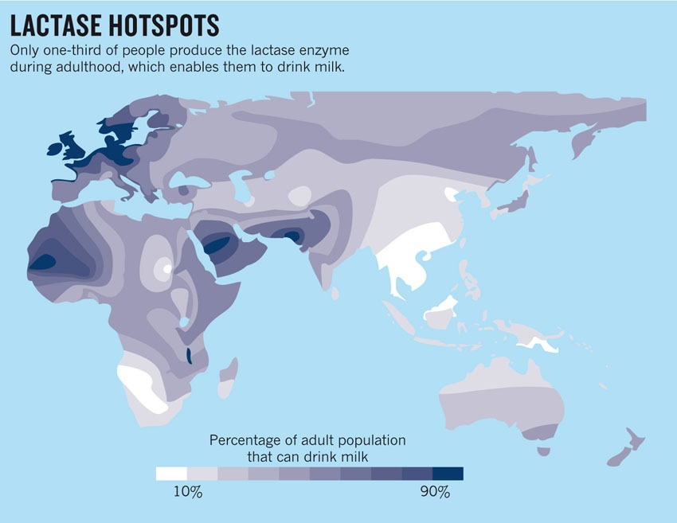
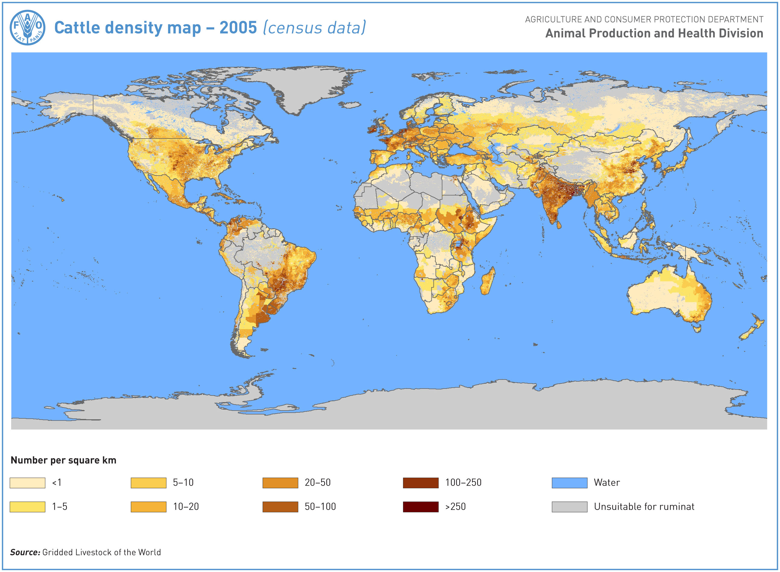
Discussion Questions:
1. What do you now know about lactose tolerance from the segment you just watched?

2. Find your own country on the map (or where your family is originally from, if your country is not on the first map). What is the prevalence of lactose tolerance there? What is the prevalence of cattle domestication in your area?

3. Compare and contrast the two maps. What do you notice about the prevalence of lactose tolerance versus the areas with the most cattle domestication in the world?

4. How might the domestication of cattle play a role in human evolution? Keep in mind that cattle provide a great deal of milk for those populations. What does milk provide for the people that ingest it?

5. Are there other (not just availability of milk) selective environmental pressures that exist in your part of the world that you think will have, or had have, an impact on human survival?

