Experiment #1

Experiment Title: Verifying Motion Direction of an Object in the Absence of Centripetal Force
Objective: Determine the motion direction of an object in the absence of centripetal force (Proving non-existence of Centrifugal Force)
Apparatus:
- Plastic tube (i.e. a pen, after removing the ink cartridge so that it is open from both sides)
- Two meters of string
- 50g OR 100g hooked mass (A mass that can be tied with a rope)
- Small iron nail, a toothpick or a small plastic ball
Procedure:
- Tie a hooked mass with a string.
- Insert the other side of the string into the plastic tube until about half of the string is inserted.
- Tie a light nail (or a toothpick or a small plastic ball) with the other side of the string. (The purpose of this is to prevent pulling the rope from the tube during the circular motion of the metal mass).
- Hold the plastic tube from the middle of the string.
- Rotate the metal mass in a horizontal circular motion above your head while keeping the hanging side with the nail steady in the other hand. (As in the figure).

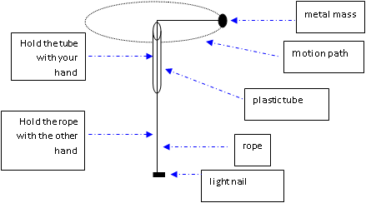

- At a certain point for the metal mass and while rotating, let go of the string. Observe the motion direction of the metal mass.
- Repeat the experiment several times to confirm the correct direction.
Safety Remarks:
- Wherever you conduct the experiment, ensure that you are at a safe distance from people, windows, doors, furniture, etc.
- Make sure that you tied the mass and the nail firmly so that it cannot escape during motion.
Conclusion: Write a description for the metal mass motion after releasing it from uniform circular motion.
Additional Question:
From this experiment, draw the direction of motion of the metal mass movement when releasing it in the following positions:

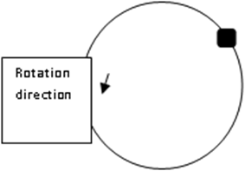
Rotation direction
Rotation direction

Rotation direction

Rotation direction

Rotation direction

Experiment #2
Experiment Title: Centripetal Force
Objective:
- Calculate centripetal force during uniform circular motion.
- Compare centripetal force with another known force.
Apparatus:
- Plastic tube (i.e. a pen, after removing the ink cartridge so that it is open from both sides)
- One meter of string
- Two hooked masses: 50g and 100g. (They can be tied with a rope)
- A stop watch
Procedure:
- Tie the big hooked mass (100g) with one side of the string.
- Insert the other side of the string into the plastic tube.
- Tie the small hooked mass (50g) with the other side of the string so that it is hanging from the plastic tube.
- Choose the radius of the circular path i.e. the string length at the upper side (according to the table below) and hold the plastic tube from its edge to prevent the rope from sliding.
- Rotate the big metal mass (100g) in a horizontal circular motion above your head while keeping the hanging side without touching it.
- When you feel that the motion is steady and uniform, releasethe rope from the plastic tube side to be free while rotating as in the figure below.

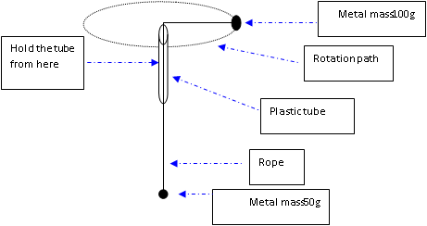

- When the velocity is constant, ask your colleague to start timing at a certain point you agree upon and simultaneously count 10 completed cycles by the big metal (100g) mass.
- Repeat the experiment four times and record the results in the table below. Make sure that all the measurements are expressed in the International System of units (SI).
Weight of hanging mass  W =m g | Centripetal Force(F)  F=$\frac{m v^{2}}{r}$ | Velocity  (v)  V=$\frac{10×2πr}{t}$ | time (t)  (10 cycles) | radius (r)  (rope length from upper side) | Trial
0.49 N |  |  |  | o.3 m
0.49 N |  |  |  | o.4 m
0.49 N |  |  |  | o.5 m
0.49 N |  |  |  | o.6 m
Note: m in the Centripetal Force (F) column is the rotating mass (100g =0.1 kg), while m in the last column is the hanging mass (50g =0.05 kg).
Safety Remarks:
- Ensure that you are at a safe distance from people, windows, doors, furniture…etc. inside the place in which the experiment is conducted.
- Make sure that you tied the two masses firmlyso that they cannot escape during motion.
Conclusion:
1. Compare between the calculated centripetal force and the weight of the hanging mass (m= 50g). What do you conclude?
2. What forces affect the big rotating mass?
3. What is the value of tension force on the rope? What is its relationship with centripetal force? What is its relationship with the force of hanging mass weight?
4. Why were the two masses steady during motion without the rope slipping towards one of them?
Additional Question:
- What do you expect to happen if we exchange the positions of the two masses so that the small one is at the top while the big one is at the bottom? Try it.
- What would happen if you increased the circular motion velocity? What would happen if you decreased the circular motion velocity? Try it.

