Notes on Hybrid topology:
Hybrid topology is an integration of two or more different topologies to form a resultant topology which has many advantages (as well as disadvantages) of all the constituent basic topologies rather than having characteristics of one specific topology. This combination of topologies is done according to the requirements of the organization.
For example, if there is a ring topology in one office department while a bus topology in another department, connecting these two will result in Hybrid topology. Star-Ring and Star-Bus networks are most common examples of hybrid network.
These are two examples of hybrid topology:
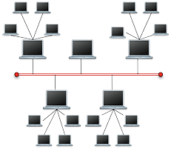
Star-Bus: The star bus topology is combined with the linear bus in large networks. In such cases the linear bus provides a backbone that connects multiple stars.
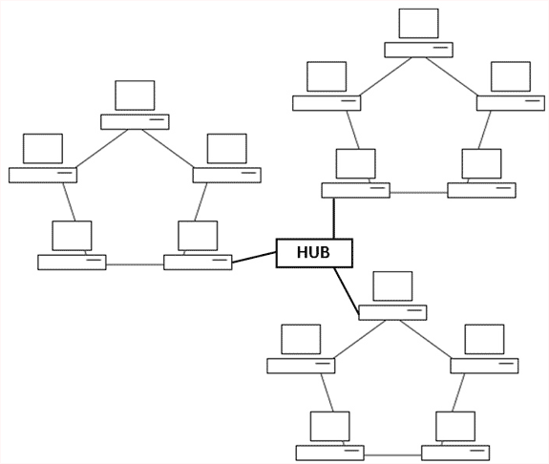
Star Ring: The Star Ring is a combination of ring and star topologies. The hubs in a star ring are connected in a star pattern by the main hub.
Advantages of Hybrid Network Topology
- Reliable: Unlike other networks, fault detection and troubleshooting is easy in this type of topology. The part in which fault is detected can be isolated from the rest of network and required corrective measures can be taken, without affecting the functioning of rest of the network.
2) Scalable: It is easy to increase the size of network by adding new components, without disturbing existing architecture.
3) Flexible: Hybrid Network can be designed according to the requirements of the organization and by optimizing the available resources. Special care can be given to nodes where traffic is high as well as where chances of fault are high.
4) Effective: Hybrid topology is the combination of two or more topologies, so we can design it in such a way that strengths of constituent topologies are maximized while there weaknesses are neutralized. For example we saw Ring Topology has good data reliability (achieved by use of tokens) and Star topology has high tolerance capability (as each node is not directly connected to other but through central device), so these two can be used effectively in hybrid star-ring topology.

Disadvantages of Hybrid Topology
1) Complexity of Design: One of the biggest drawbacks of hybrid topology is its design. It is not easy to design this type of architecture and it is a tough job for designers. Configuration and installation process needs to be very efficient.
2) Costly Hub: The hubs used to connect two distinct networks, are very expensive. These hubs are different from usual hubs, as they need to be intelligent enough to work with different architectures and should be function even if a part of network is down.
3) Costly Infrastructure: As hybrid architectures are usually larger in scale, they require a lot of cables; cooling systems, and sophisticate network devices.

