How to measure height?
Fei Liang
Verakin High School of Chongqing, Sichuan, China

Activity 1

Q : The Broken Bamboo Problem, taken from the Arithmetic in Nine Sections, is given below:

There is a bamboo 1 zhang high, the upper end of which being broken reaches the ground 4 chi from the stem. Find the height of the break. (zhang and chi are ancient Chinese length units, 1 chi = 33.3 cm,1 zhang = 10 chi = 3.33 m)

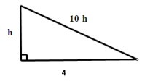
A：As shown in the figure, let the height of the broken bamboo be h chi, because the original height of the bamboo is 1 zhang and 1 zhang = 10 chi, the length of the
Hypotenuse should be (10-h) chi. According to Pythagorean Theorem, we can build the following equation:
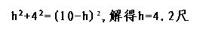
So the height of the broken bamboo should be 4.2 chi.

Activity 2

Q: If the pulling rope of a flagpole is unfixed, how to get the height of the flagpole by building a right triangle with the rope and the flagpole?
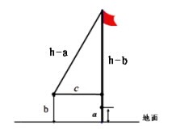
A: The key to the problem is to construct a right triangle. Let the length of the rope be “h”. First, straighten the rope, use a tape measure to measure the distance between the bottom of the rope and the bottom of the flagpole, then we record it as””; Second, pull the rope horizontally away from the flagpole to a certain distance from the pole with the length of the rope unchanged, now the flagpole and the rope forms a right triangle. Use a tape measure to measure the distance between the endpoint of the rope and the ground, we record it as “b”, and the horizontal distance between the endpoint of the rope and the flagpole as “c”. So the following equation can be built by Pythagorean Theorem.

（the length of the rope is unchanged）

So the solution of the above equation : 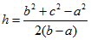 ,

Activity 3

Q：Assuming the weather is sunny and we only have a tape measure. How do we get the height of the flagpole by the relationship between the height of a person (or a pole whose height is known), the length of a person’s shadow (or a pole’s shadow) and the length of the flagpole’s shadow? (hint: similar triangles)

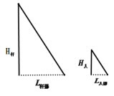

A: As show in the above figure, at the same time, two similar right triangles can be formed by the flagpole and its shadow, the person and his(her) shadow. According to the knowledge of similar triangles, we can finally get the height of the flagpole.

Measuring steps：Use a tape measure to get a person’s height ，also the length of his(her) shadow ，and the length of the flagpole’s shadow_{。According to the}

knowledge of similar triangles: 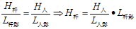 。

Activity 4

Q：How to measure the height of the teaching building?

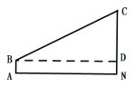

A：As show in the figure, the teaching building, our eyesight, and the horizontal line form a right triangle, among which only the length of the horizontal line AN can be easily measured, and the other two cannot. Because the height of the protractor is 1.5m, If we can use a protractor (tilt sensor) to measure the elevation angle of the building and also the distance from the bottom of the building to the protractor , then we can calculate the height of the building. As shown in the figure, we can put a protractor at the place of A and get the elevation angle ∠CBD=α; measure the height of this protractor AB=DN=b, and the distance between A and the building, so AN=BD=, then we can get the height of the building by this equation: the height of the teaching building CN=CD＋DN=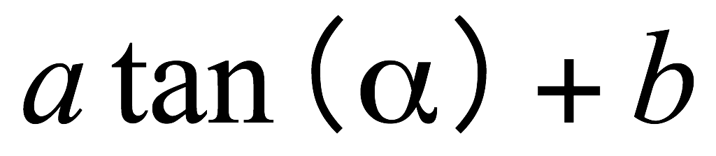

When the space is even and big enough, for more convenience, we can let α≈ 45 degree, so tanα=1, then the height of the teaching building CN=a+b.

Measuring Steps：

- Put a protractor at the place A and get the elevation angle ∠CBD=α;

② measure the height of the protractor AB=DN=b, and the distance between A and the building AN=BD= ;

③ According to the equation CN=CD＋DN= ，the height of the teaching building can be obtained.

Activity 5

Q：If it’s very difficult for us to measure the distance between A and N, can we alter the mathematic model to get the height of the tree by using a protractor?

A：Although the distance between A and N is difficult to measure by the tape measure, the elevation angles at two places can be obtained. However, if we want to get the height of the building, we need to know at least one length that can be measured. So we can form two right triangles who share the same side MN. Then we can get the height of the tree by the following steps.

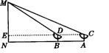

Measuring steps：

① Put the protractor at place A, measure the elevation angle of M, ∠MCE=α ( please ensure your eyes (sightline), two pointers, and point M to be on the same straight line.);

② Move the protractor to place B (Please make sure that B is between A and N, and A,B,N are on the same line), measure the elevation angle of M, ∠MDE=β;

③ Measure the height of the protractor: EN=AC=BD=a (here is 1.5m) and The distance between A and B, AB=b. So
Because MN=ME＋a, the height of MN can be obtained.

